**WOT Graphic Proposal C**

**For this third option, we stay simple in the graphic and put more contrast in the colours and the shadows to follow the yeres imperment specification.**

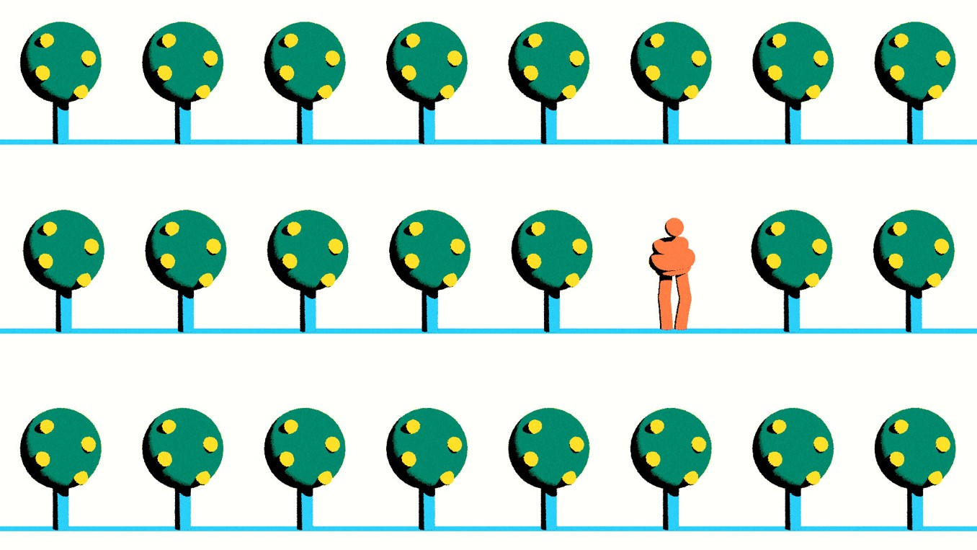

NB Sprinkler rotating



